Bajra International College

Jorpati-2, Kathmandu

**Lab Report Of “Computer Networking ”**

**Submitted By:** **Submitted To:**

Sonam Tamang Deepak Bomjan

BCA 5th Semester

**Table of Content**

* Introduction to packet tracer simulation tools.
* Creating and configure a simple peer-to-peer network having two PC’s and testing the connectivity between them.
* Creating a local area netwrok and testing the connectivity within the network.
* Interconnecting two different LAN’s testing the connectivity between them.
* Static Routing
* Implementing Dynamic Routing Protocol RIP
* Implementing Dynamic Routing Protocol OSPF.
* Implementing Dynamic Routing Protocol BGP.
* Configure DHCP server to assign IP address dynamically.
* Configure DNS server for the domain name mapping.
* Configure FTP server.
* Configure Web server.
* Capturing a packet and perform header analysis using Wireshark.

**Lab 1**

**Introduction to packet tracer simulation tools.**

**Objectives:**

## To know about packet tracer .

## To know the working environment of packet tracer and how to work with it.

## **Background theory :**

## Packet Tracer is cisco system cross platform visual simulation application for creating network topologies and simulating modern computer networks. User can use the software to replicate cisco router and switch configurations using a simulated command line interface. Packet tracer’s user interface is drag and drop, allowing users to add and remove simulated network devices as needed. The interface of cisco packet is shown below in figure:

## 

## **Figure : Interface of CISCO Packet Tracer**

## 

**Observation and Finding :**

Connecting to Router, Switch ,PC , and server and testing their connectivity .

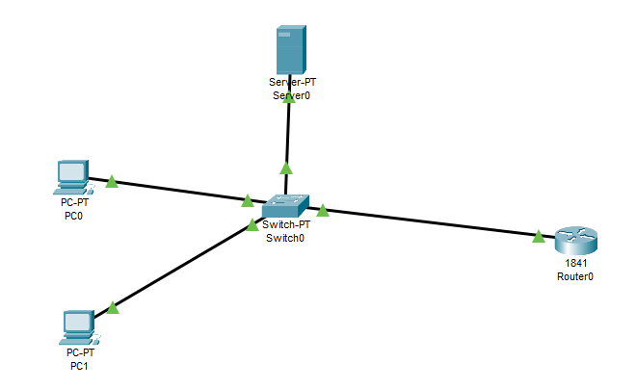

**Figure: Connectivity Betweeen different devices**

**Ouput :**

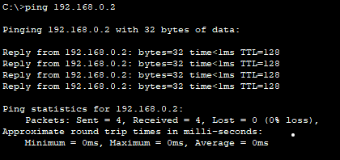

**Discussion :**

The basic of Cisco Packet Tracer is demonstrated in this lab. We also use many tools like Router, Server, Pc and many Switch to know about the working environment of The Cisco Packet Tracer.

**Conclusion:**

The aim of this lab is to become familiar with Cisco Packet Tarcer and it’s working environment.

**Lab 2**

**Creating and configure a simple peer-to-peer network having two PC’s and testing the connectivity between them.**

**Objectives:**

* Implemnt peer-to-peer network using packet tracer .
* Testing connectivity between different computers present in the network.

**Background study :**

A collection of computers is joined together with equal permission and responsibilities of data processing in peer-to-peer(P2P) networking. In contrast to taditional client server networking , no device ina P2P netwroking is completely dedicated to serving or receiving data.

**Observation and Findings:**

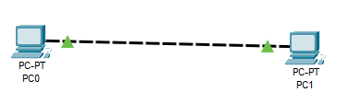Implementing peer-to-peer network in between two PC’s and testing connectivity between them.

**Figure : peer-to-peer network**

**Ouput :**

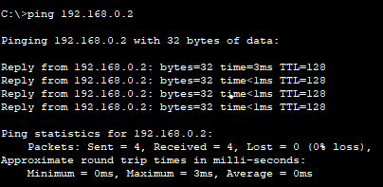

**Discussion :**

Use of peer-to-peer network is demonstrated in this lab. We use tow PC’s and connect between them and assign them IP address and test their connectivity .

**Conclusion:**

The aim of this lab is to become familiar with perr-to-peer netwrok using two PC’s.

**Lab 3**

**Creating a local area netwrok and testing the connectivity within the network.**

**Objectives:**

* To create a local area network using packet tracer and testing connectivity within network.
* To study in detail about local area network.

**Background study:**

The term “local area network “ refers to a network that is limited to a single location. A LAN is a network that is contained inside a small geographic region, usually within the same building , and is made up of two or more connected computers. LAN’s are commonly used in home WIFI networks and samll business netwrok.

**Observation and Findings:**

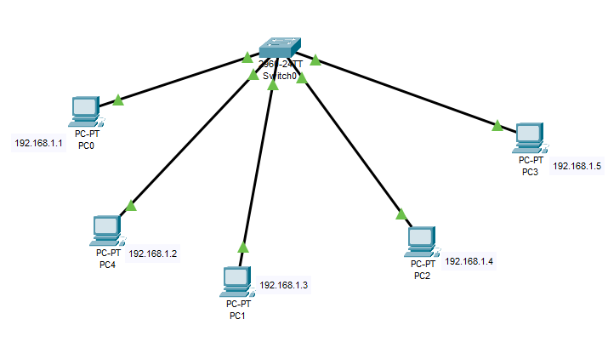Implement a local area network and testing the connectivity between the network.

**Figure: Local area Network**

**Output:**

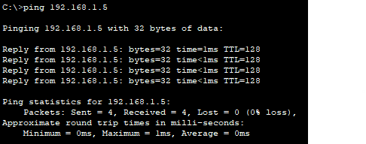

**Discussion:**

Use of LAN and testing the connectivity within the network is demonstrated in this lab.

**Conclusion:**

The aim of this lab is to become familiar with Local Area Network.

**Lab 4**

**Interconnecting two different LAN’s testing the connectivity between them.**

**Objective:**

* To connect two different LAN’s using router.
* To send data from one LAN to another.

**Background Study:**

LAN interconnection to inter working is the process of interconnecting two different LAN’s using router. In this lab two different LAN’s are used to test the connectivity between them.

**Observation and Findings:**

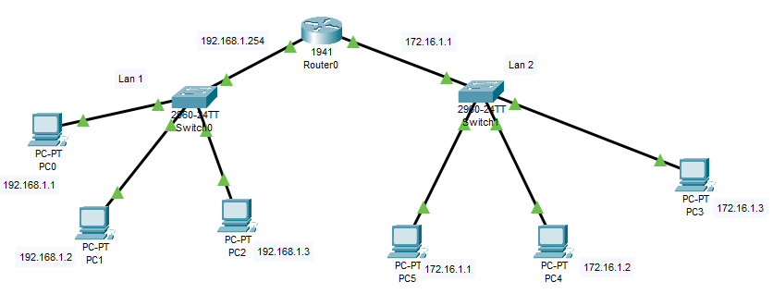Interconnecting two different LAN’s and testing their connectivity between them.

**Figure: Interconnection of Local Area Network**

**Ouput:**

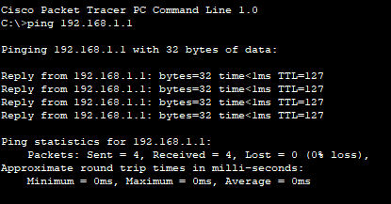

**Discussion :**

Interconnecting two different LAN’s and testing the connectivity between them.

**Conclusion:**

The aim of this lab is to beacome familiar with LAN’s and their internetwroking.

**Lab 5**

**Router configuration using Command Line Inaterface.**

**Objective:**

* To know about Router Configuration.
* To know about Command used in CLI.

**Backgroung Theory:**

Communication between network’s would not be possible without a router determing the best path to the destination and forwarding traffic to the next router along that path. The router is reaponsible fot the routing of traffic between networks. You need to configure the router so that it can communicate with your network components.

**Process For Router Configuration using CLI.**

STEP 1: enable router using command enable or en.

STEP 2: enter command configure terminal.

STEP 3: enter command line Console 0.

STEP 4: Set a password as you like.

STEP 5: exit

STEP 6: enable routing using password.

STEP 7: go to the terminal using configure t command.

STEP 8: set a IP address and subnet mask for GigabitEthnernet of a router.

STEP 9: enable the parts of a router using no shutdwon command.

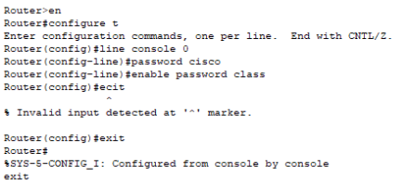STEP 10: enable IP address of a computer.

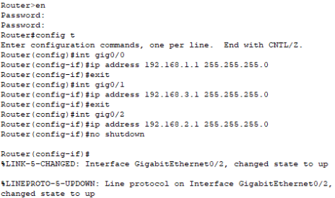

**Observation and findings:**

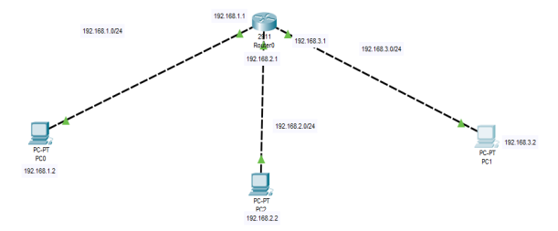Configuring routers using Command Line Interface.

**Figure 5: Configuration of a Router**

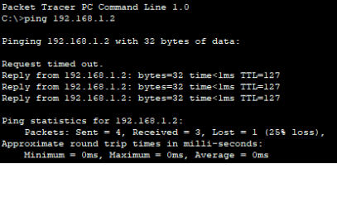**Output:**

**Discussion:**

Configuration of a Router using Command Line Interface.

**Conclusion:**

The aim of this lab is to become familiar with Command Line Interface.

**Lab 6**

**Interconnecting two different LAN’s testing the connectivity between them.**

**Objectives:**

* To know about static routing.
* To know how to give IP route to a router.

**Background Theory:**

Static Routing is type of network routing technique. Static Routing is not a routing protocol, instead it is the manual configuration and selection of a network route, usually managed by the network administrator.

**Process for Routing:**

Step 1: Set a router with IP address.

Step 2: Setup switch and desktop for communication with IP address.

Step 3: Set an another router with IP address.

Step 4: Enable parts of a routers.

Step 5: Set a static route for Router one and two.

Step 6: Communicate from one network to another.

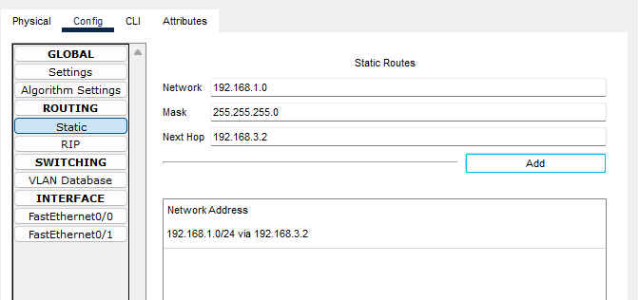**Figure : Static routes for static routing.**

**Observation and Findings:**

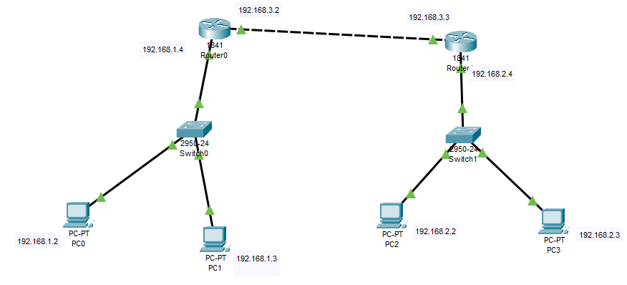Static Routing

**Figure: Static Routing**

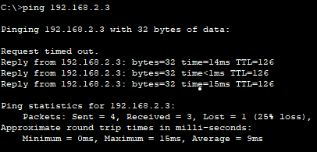**Output:**

**Discussion:**

Static Routing using CLI is implemented in this Lab.

**Conclusion:**

The aim of this lab is to become familiar with Static Routing.

**Lab 7**

**Implementing Dynamic Routing Protocol RIP**

**Objectives:**

* To know about Dynamic Routing.
* To know RIP Dynamic Protocol.

**Background Theory :**

Routing information Protocol (RIP) is a dynamic routing protocol which uses hop count as mic routing matric to find the best path between the source and the destination network. It is a distance vector routing protocol which has AD value 120 and works on the application layer of OSI model. RIP uses port number 520.

**Process for RIP routing:**

Step 1: set a minimum three router.

Step 2: set up switch and desktop for communication with IP address.

Step 3: enable ports of a routers.

Step 4: set a RIP network for routers using CLI or GUI.

Step 5: Communicate from one network to another.

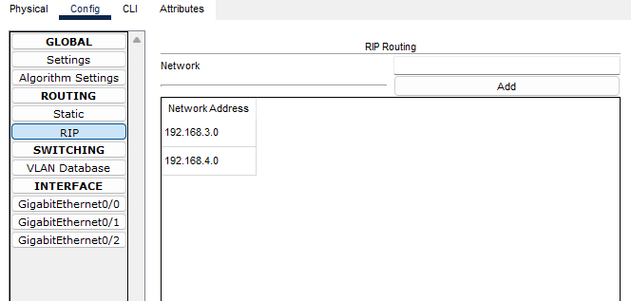

**Observation and Findings:**

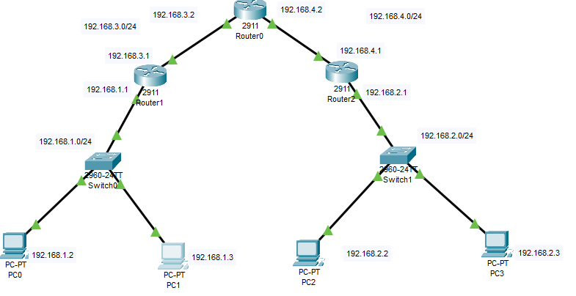RIP protocol for dynamic routing

**Figure 9: Dynamic Routing (RIP)**

**Output:**

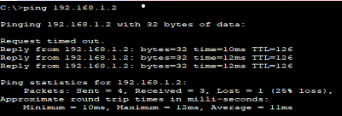

**Discussion:**

Dynamic Routing Protocol Rip is implemented in this Lab.

**Conclusion:**

The aim of this lab is ti become familiar with Dynamic Routing Protocol RIP.

**Lab 8**

**Implementing Dynamic Routing Protocol OSPF.**

**Objectives:**

* To know about Dynamic Routing.
* To know OSPF dynamic Protocol.

**Background Theory:**

The OSPF stands for Open Shortest Ptah First. It is widely used and supported routing protocol. It is an intra domain protocol, which means that it is used within an area of a network. It is an interior gateway protocol that has been designed within a single autonomous system.

**Process for OSPF Routing:**

Step1: Set a minimum three router.

Step2: Setup switch and desktop for communication with IP address.

Step3: enable ports or routers.

Step4: set a OSPF network for routers which are not directly connected first and then set connected networks using CLI.

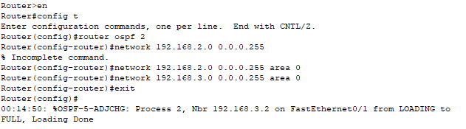Step5: Communicate from one network to another.

**Observation and Findings:**

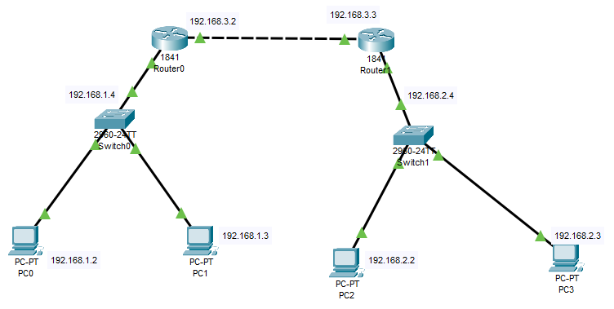OSPF protocol for dynamic routing.

**Figure: Dynamic Routing (OSPF)**

**Output:**

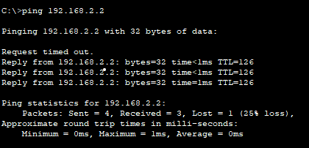

**Discussion:**

Dynamic Routing Protocol OSPF is implemented in this lab.

**Conclusion:**

The aim of this lab is to become familiar with Dynamic Routing Protocol OSPF.

**Lab 9**

**Implementing Dynamic Routing Protocol BGP.**

**Objectives:**

* To know about Dynamic Routing.
* To know BGP dynamic protocol.

**Background Theory:**

It is an inter domain routing protocol, and it uses the path-vector routing. It is a gateway protocol that is used to change routing information among the autonomous system on the internet.

**Process for BGP Routing:**

Step1: set a minimum two routers with minimum of one desktop each.

Step2: enable ports of a routers and set a IP address for both desktop and routers.

Step3: go to CLI mode of each router and set directly connected network and neighbor IP address.

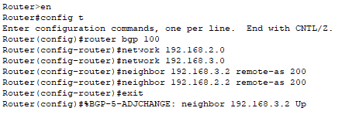Step4: communicate from one another by the help of desktop with ping command .

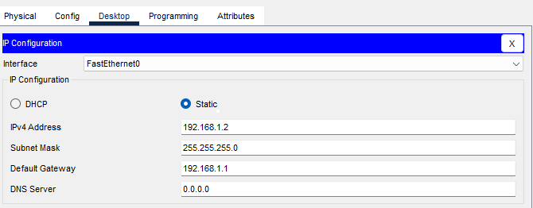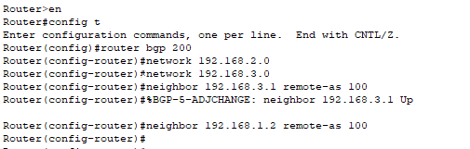

**Figure : IP configuration of PC(BGP)**

**Observation and Findings:**

BGP protocol for dynamic protocol.

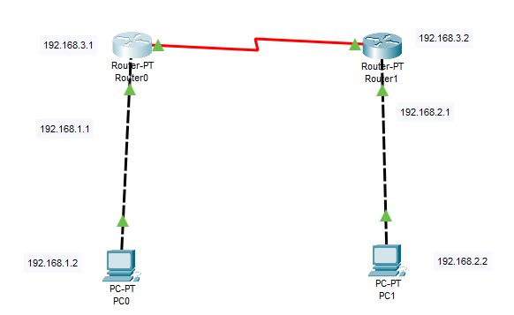

**Figure : Dynamic Routing (BGP)**

**Output:**

Without Routing

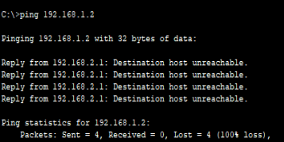

With Routing

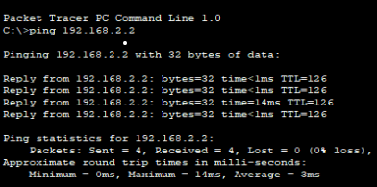

**Discussion:**

Dynamic Routing Protocol BGP is implemented in this lab.

**Conclusion:**

The aim of this lab is to become familiar with Dynamic Routing Protocol (BGP).

**Lab 10**

**Configuring DHCP server to assign IP address dynamically.**

**Objectives:**

* To know about DHCP
* To know how DHCP server assign IP address dynamically.

**Background theory:**

Dynamic Host Configuration Protocol (DHCP) is a network management protocol used to automate the process of configuring devices on IP networks, thus allowing them to use network services such as DNS, NTP and any communication protocol based on UDP or TCP. A DHCP server dynamically assigns an IP address and other network configuration parameters to each device on a network so they can communicate with other networks.

**Process for DHCP server to assign IP address:**

Step1: Set a one router with one server and a desktop as required.

Step2: enable ports of routers and set a IP address for both server and routers.

Step3: Go to services of a server and on the service and assign the IP address of router in the server and set the start IP address.

Step4:enable the DHCP in the IP configuration section of a desktop.

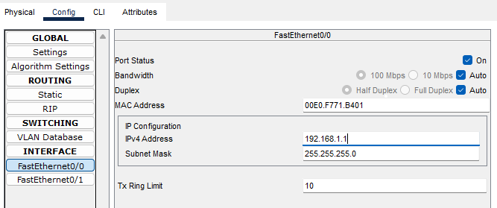

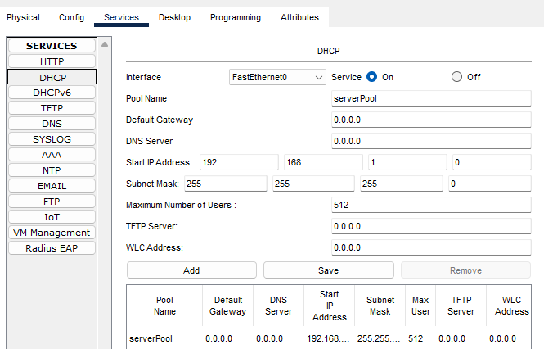**Figure : Router Configuration (DHCP)**

**Figure: Server Configuration (DHCP)**

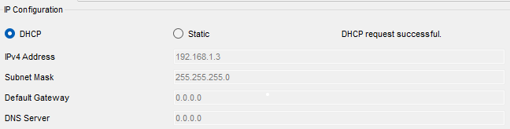

**Figure : IP assignment Dynamically (DHCP)**

**Observation and Findings:**

DHCP server IP assignment.

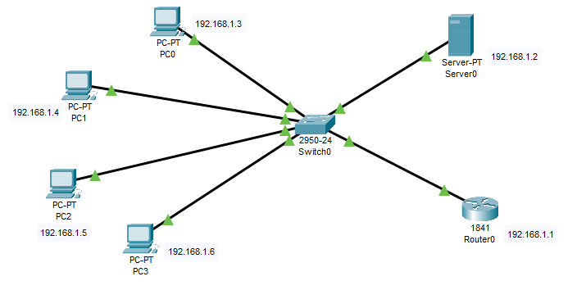

**Figure: DHCP Server configuration**

**Output:**

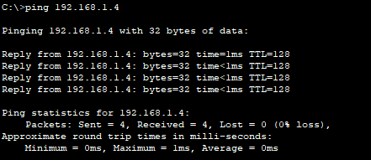

**Discussion:**

DHCP server configuration is implemented in this lab.

**Conclusion:**

The aim of this lab is to become familiar with DHCP server configuration.

**Lab 11**

**Configuring DNS server for domain name mapping**.

**Objectives:**

* To know about DNS server
* To know how DNS server is used for domain name mapping.

Background Theory:

The Domain Name Server (DNS) is the Internet’s system for mapping alphabetic names to numeric Internet Protocol (IP) addresses like a phone book maps a person’s name to phone number. For example, when a Web address (URL) is typed into a browser, a DNS query is made to learn an IP address of a Web server associated with that name.

Using the [www.example.com](http://www.example.com) URL, example.com is the domain name and www is the hostname. DNS resolution maps [www.example.com](http://www.example.com) into an IP address (such as 192.0.2.1)

**Process for DNS server for Domain Name Mapping**

Step1: Set a one switch with one server and set a desktop as required.

Step2: Set a DNS IP address for a server and enable the DNS service

Step3: Go to services of a server and set the domain name and address for a DNS server.

Step4: Set a IP address for a desktop with DNS IP address.

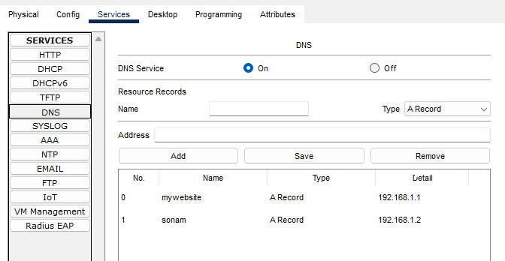

**Figure: DNS Server configuration (DNS)**

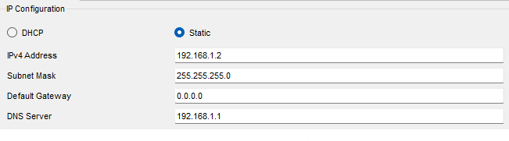

**Figure: DNS PC configuration (DNS)**

**Observation and Findings:**

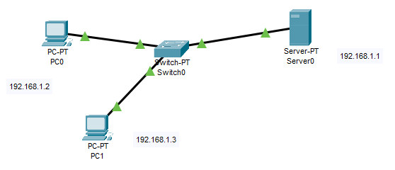DNS server for domain name mapping

**Figure: DNS Server for Domain name mapping (DNS)**

**Output:**

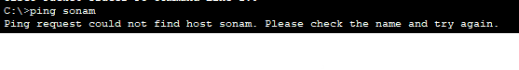Without Domain name:

With Domain name:

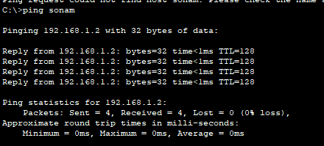

**Discussion:**

DNS server for domain name mapping is implemented in this lab.

**Conclusion:**

The aim of this lab is to become familiar with DNS server.

**Lab 12**

**Configuring FTP server**

**Objectives:**

* To know about FTP server.
* To know how FTP server is used to perform different file opration.

**Background Theory:**

The primary purpose of an FTP server is to allow users to upload and download files. An FTP server is a computer that has a file transfer protocol(FTP) address and is dedicated to receiving an FTP connection. FTP is protocol used to transfer files via the internet between a sever (sender) and a client(receiver) .An FTP server is a computer that offers available for download via an FTP protocol, and it is a common solution used to facilitate remote data sharing between computers.

**Process for FTP server for different file operation.**

Step1: Set one switch with one server and a router and set a desktop as required.

Step2: set server IP address for a server and Router.

Step3: Go to services of a server and set the username and password along with read, write, list, etc. as required in FTP section.

Step4: set a IP address for a desktop with Router IP address.

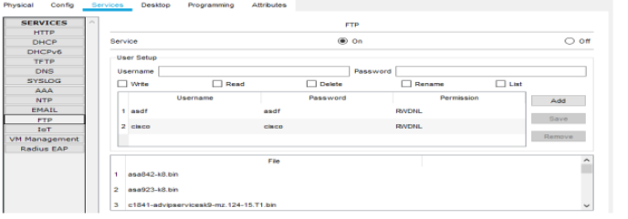

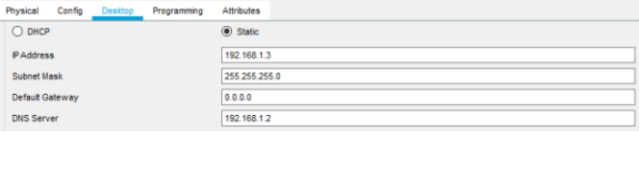**Figure : FTP server configuration(FTP)**

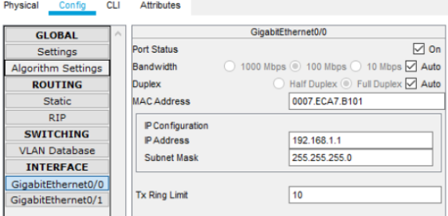**Figure : PC configuration (FTP)**

**Figure : Router Configuration (FTP)**

**Observation and Findings:**

FTP server for different file operation.

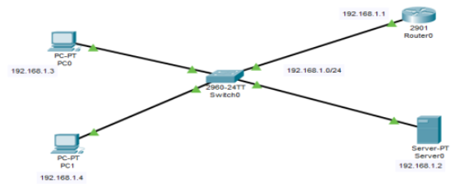

**Figure : FTP server for different file operations**

**Output:**

For reading file

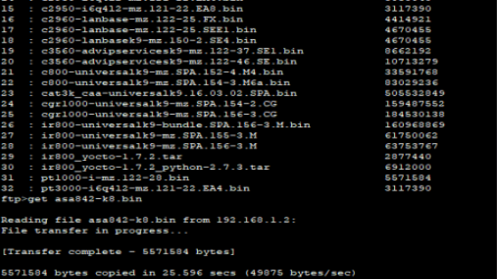

For deleting file

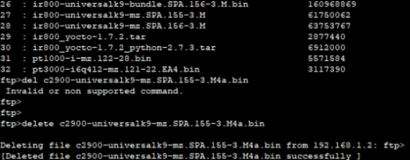

**Discussion:**

FTP server for different file operations is implemented in this lab.

**Conclusion:**

The aim of this lab is to become familiar with FTP server file operation.

**Lab 13**

**Configuring Web server.**

**Objectives:**

* To know about web server.
* To know how web server perform http operation.

**Background Theory:**

A web server is software and hardware that uses HTTP(Hypertext Transfer Protocol) and other protocols to respond to client request made over the World Wide Web. The main job of a wb server is to display website content through storing, processing and delivering webpages to users. Besides HTTP, web servers also support SMTP (Simple Mail Transfer Protocol) and FTP(File Transfer Protocol), used for email, file transfer and storage).

**Process for configuring web server:**

Step1: set one switch with two servers and a router and set a desktop as required.

Step2: set server IP address for both of a server and set one as DNS server and another as Web server .

Step3: set router IP address.

Step4: set an IP address for a desktop with router IP address as default gateway.

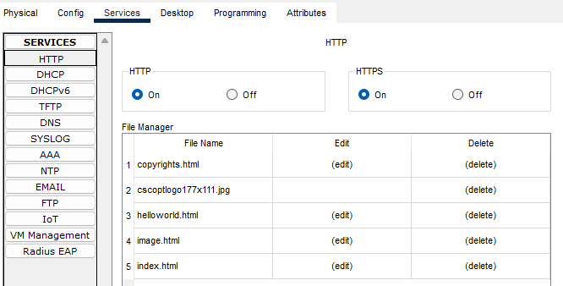

**Figure: Web server configuration**

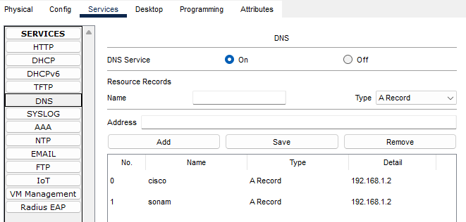

**Figure: Web server DNS configuration**

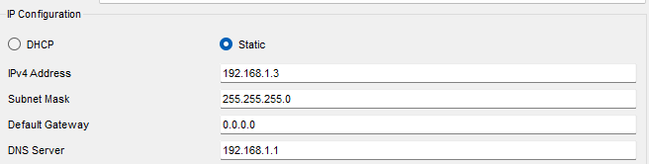

**Figure: web server PC configuration**

**Output:**

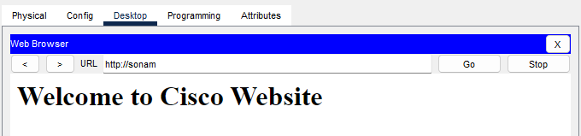

**Discussion:**

Web server configuration is implemented in this lab.

**Conclusion:**

The aim of this lab is to become familiar with web server.

**Lab 14**

**Capturing a packet and perform header analysis using Wireshark.**

**Objectives:**

* To know about Wire shark.
* To know about wire shark interface.

**Background Theory:**

Wireshark is a free and open-source packet analyzer. It is used for network troubleshooting, analysis, software and communication protocol development, and education.

**Process for capturing packets in Wireshark**

Step1: Open Wireshark application.

Step2: Choose the interface of a Wi-Fi with live signal.

Step3: click on a Wi-Fi to see the packet flow.

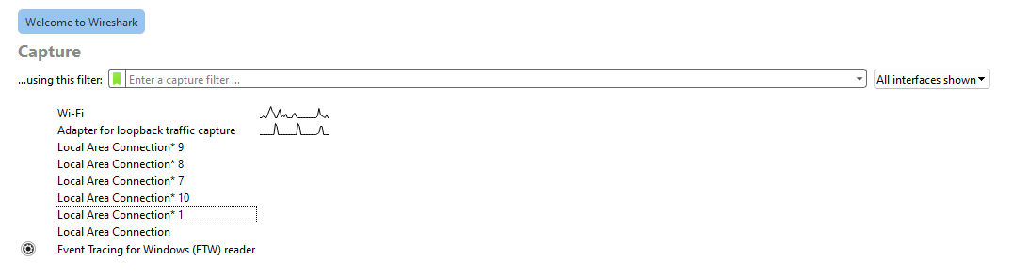Step4: observe a flow of packets and detail of a packet in it.

**Figure: Wireshark interface**

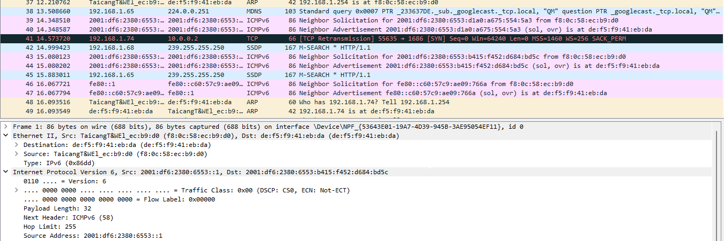

**Figure: flow of packet in Wireshark**

**Discussion:**

Basic of Wireshark is implemented in this lab.

**Conclusion:**

The aim of this lab is to become familiar with Basic operation of Wireshark.